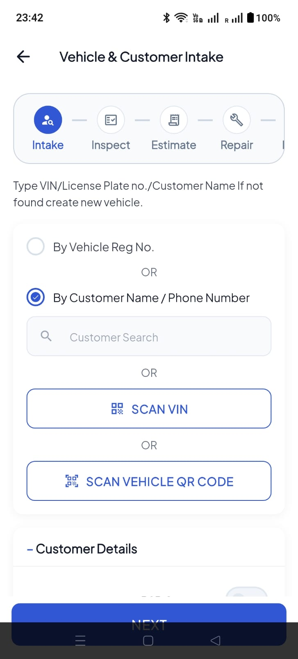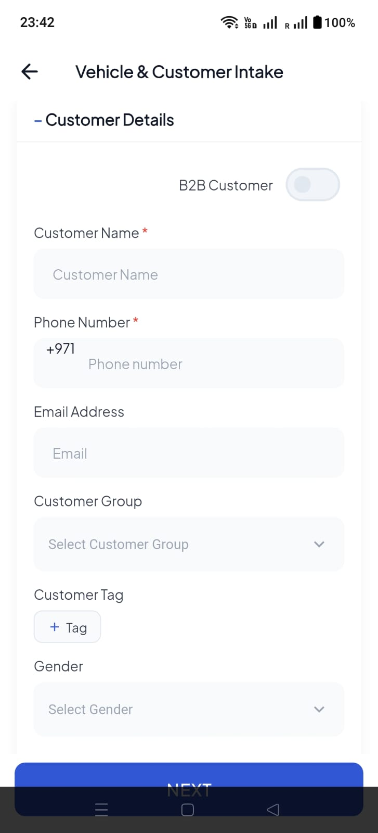
- CUSTOMER SEARCH - MOBILE NUMBER OR NAME - PLATE NUMBER OR VIN NUMBER ANY ONE CAN BE SEARCH RIGHT ?
- CUSTOMER TAG REMOVE

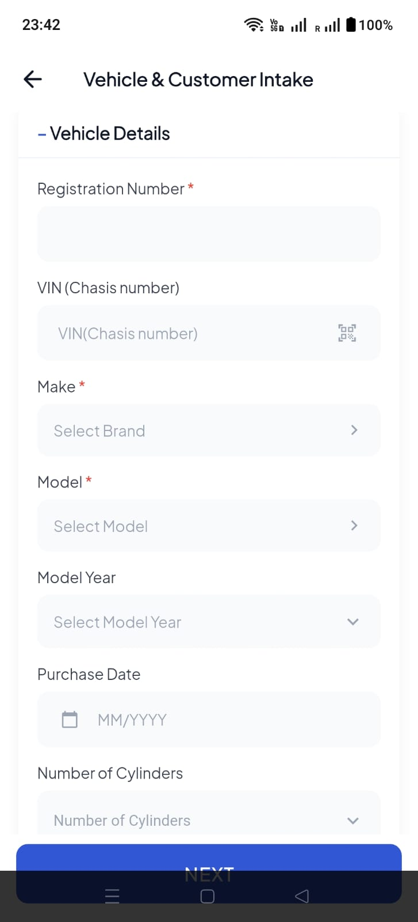
- BEOFRE REGISTRATION NUMBER WE NEED EMIRATES + CODE = PLATE NUMBER
YOU CAN MAKE IT ON BOX ALSO
- REMOVE PURCHASE DATE
- ADD COLOR
- ADD FULE TYPE
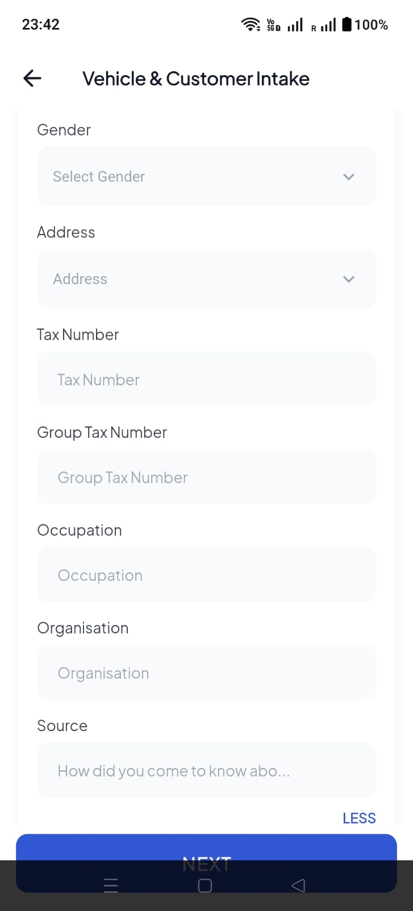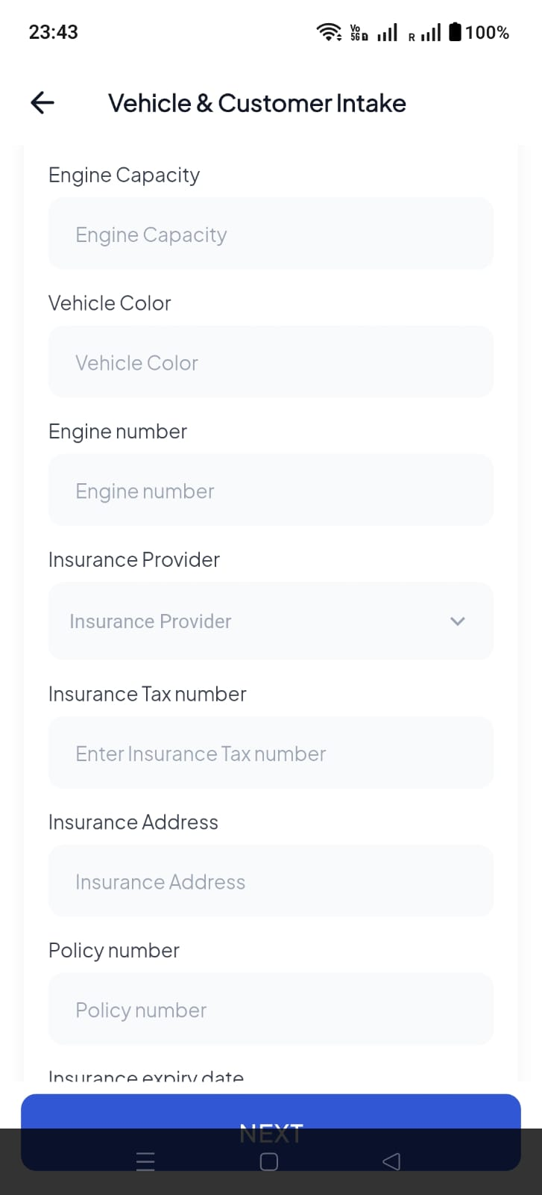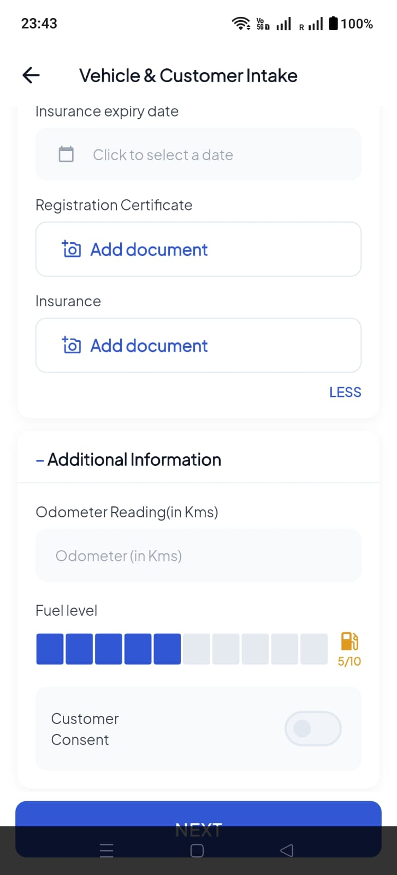
- REMOVE GROUP TAX NUMBER
- REMOVE OCCUPTATION
- REMOVE ORGANISATION
- ADD – MARKUP TYPE
- ADD- ORDER TYPE –
- ADD – JOB CATEGORY (DROP DOWN OF REGULAR, INSURANCE, WARRANTY, CONTRACT)
- INSURANCE MAKE A SEPRATE BOX IF TICK THEN APPEAR DATA
- INSURNACE NAME
- LPO NUMBER
- POLICY NUMBER
- ACCIDENT NUMBER
BEFORE SAVING JOB CARD ADD
- PHOTOS / VIDEO OPTIONS MULTIPLE
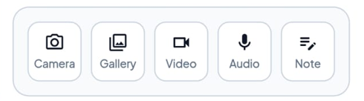
- ADD JOB DESCRIPTION
- CUSTOMER DIGITAL SIGNATURE
- ADVISOR DIGITAL SIGNATURE
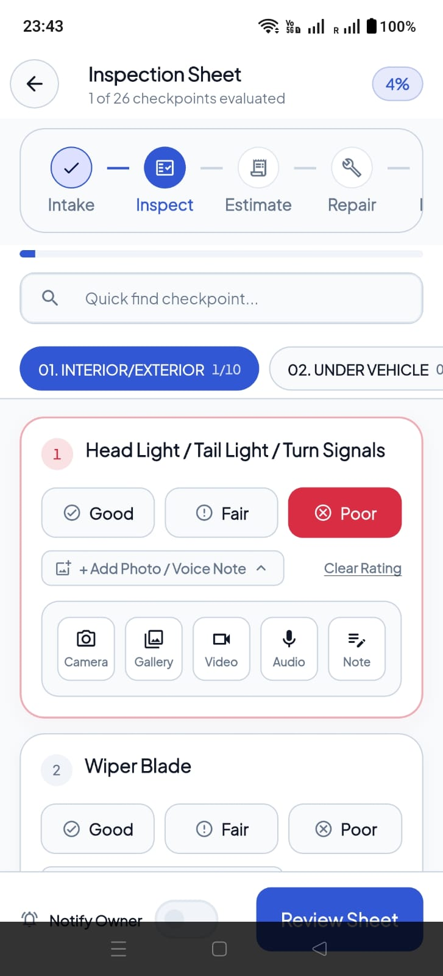
- INSPECTION WIL BE LINK WITH SOFTWARE FOR THE DETAILED LISTING OF CHECK LIST

JOB CARD / INSPECTION AND ESTIMATION APPROVAL IN CUSTOMER LOGIN NEED
SPECIALLY ESTIMATION APPROVAL LINE BY LINE ITEM WE WILL DISCUSS

